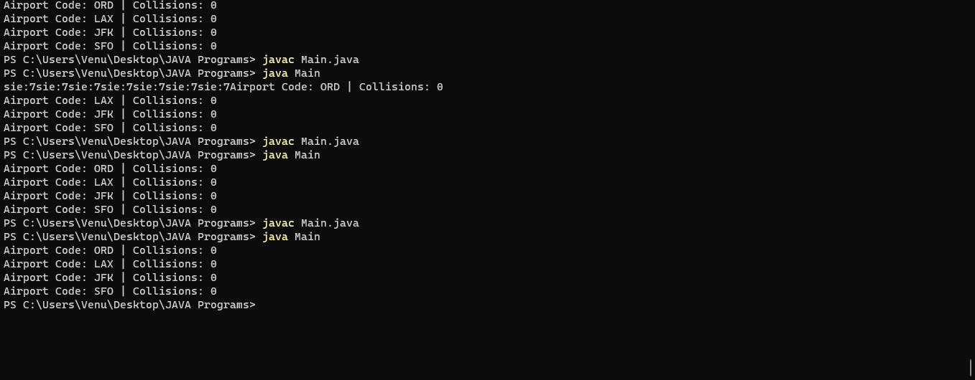

import java.io.BufferedReader;

import java.io.FileReader;

import java.io.IOException;

import java.util.ArrayList;

import java.util.LinkedList;

class HashTable {

private int size;

private ArrayList<LinkedList<String>> table;

public HashTable(int size) {

this.size = size;

table = new ArrayList<LinkedList<String>>(size);

for (int i = 0; i < size; i++) {

table.add(new LinkedList<String>());

//System.out.print("sie:"+size);

}

}

public void add(String key) {

int index = hash(key);

table.get(index).add(key);

}

private int hash(String key) {

int hash = 0;

for (int i = 0; i < key.length(); i++) {

hash = (hash + key.charAt(i)) % size;

}

return hash;

}

public int collisions(String key) {

int index = hash(key);

return table.get(index).size();

}

}

public class Main {

public static void main(String[] args) {

HashTable hashTable = new HashTable(7);

String csvFile = "C:/Users/Venu/Desktop/JAVA Programs/airportCodes.csv";

String line = "";

String cvsSplitBy = ",";

try (BufferedReader br = new BufferedReader(new FileReader(csvFile))) {

while ((line = br.readLine()) != null) {

// use comma as separator

String[] airport = line.split(cvsSplitBy);

//System.out.println(airport.length);

//hashTable.add(airport[7]);

}

} catch (IOException e) {

e.printStackTrace();

}

String[] keys = {"ORD", "LAX", "JFK", "SFO"};

for (String key : keys) {

System.out.println("Airport Code: " + key + " | Collisions: " + hashTable.collisions(key));

}

}

}